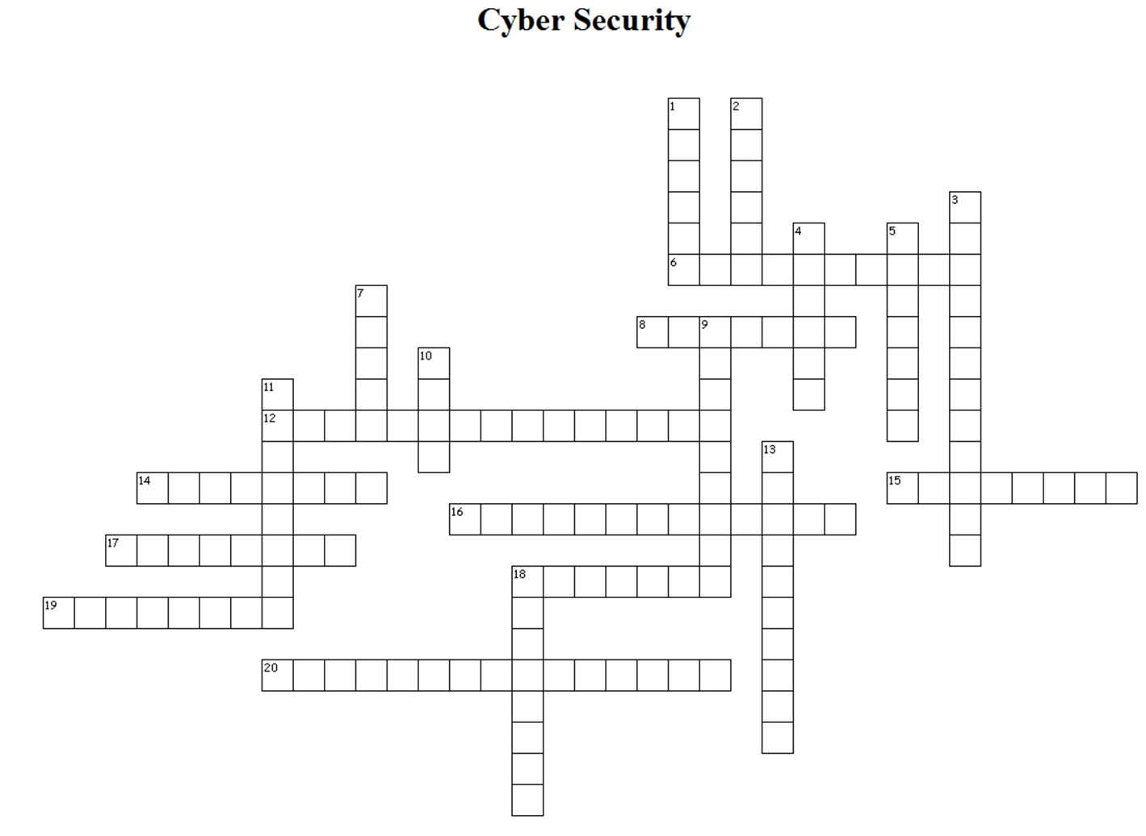

Across:

6. malicious computer program that restricts or disables your computer and then demands, that you pay a fee to fix the problem  
8. voice phishing; recorded messages to trick you  
12. logs strokes on your keyboard  
14. malicious programs to route you to fraudulent sites that look real  
15. emails used to trick you to give out personal information  
16. plays the role to fool you  
17. the manipulation of telephone Caller ID to display a false name or number for the caller  
18. malware that collects information without your knowledge  
19. illegal placement of unauthorized charges on your telephone bill  
20. watching your keystrokes

Down:

1. illegally breaks into computers

2. Software corrupting data on your hard drive not a virus nor a worm  
3. reel in a big fish to gain passwords  
4. **a** network of computers infected with hidden software to secretly send spam  
5. Malicious software  
7. A computer program that can replicate itself and spread from computer to computer or file to file

9. a type of malware that is supposed to be "protection" software  
10. like a virus, it can replicate itself and spread but without any action by you  
11. capture data on your ATM or credit card by a device that is installed on card-reading machines  
13. an attacker seeking entry to a restricted area  
18. SMS text message scam